Ideation Phase
Brainstorm & Idea Prioritization Template

Date | 2 February 2026
Team ID | LTVIP2026TMIDS61992
Project Name | visualization tool for electric vehicle charge and range analysis
Maximum Marks | 4 Marks

Step-1: Team Gathering, Collaboration and Select the Problem Statement


Step-2: Brainstorm, Idea Listing and Grouping
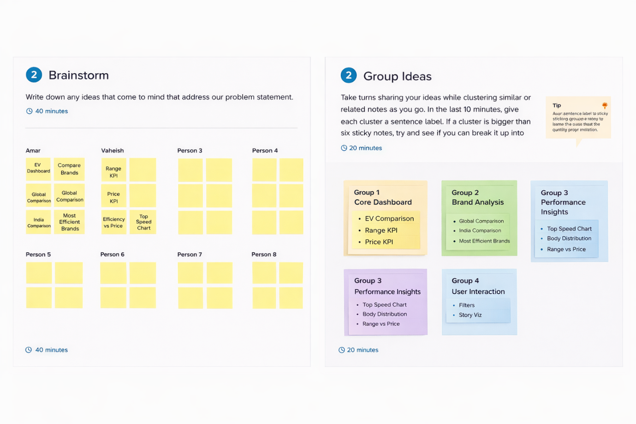

Step-3: Idea Prioritization
